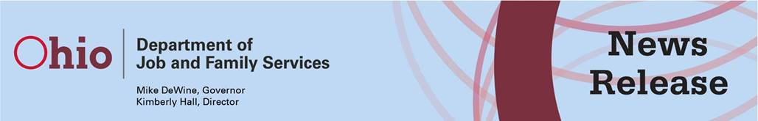

|  |  |
| --- | --- |
| **FOR IMMEDIATE RELEASE**  **April 7, 2020** | **Bret Crow,** [**Bret.Crow@jfs.ohio.gov**](mailto:Bret.Crow@jfs.ohio.gov) **or  Angela Terez,** [**Angela.Terez@jfs.ohio.gov**](mailto:Angela.Terez@jfs.ohio.gov) |
|  | **(614) 307-9562** |

**Ohioans Receiving Food Assistance to Receive Additional Support in April**

COLUMBUS, OHIO – Ohioans enrolled in the Supplemental Nutrition Assistance Program (SNAP) will soon receive additional support to help them during the pandemic, the Ohio Department of Job and Family Services (ODJFS) announced today. Those who did not receive the maximum monthly allotment for their household size in March will be issued an additional payment beginning this week. In addition, Ohio requested and obtained federal approval to run a Disaster Household Distribution Program, which will allow the state to waive administrative verifications normally required at food banks, to streamline the process and limit person-to-person contact.

“We are thrilled to be able to offer this additional assistance and make it easier for Ohioans to get the help they need,” said ODJFS Director Kimberly Hall. “We know many families are struggling, and we hope these measures will help them stretch their monthly food budgets as we weather this storm.”

The federal Families First Coronavirus Response Act gives states the option to provide SNAP households with the maximum allotment, based on their household size. Households not currently receiving the maximum allotment will receive additional benefits in April to bring their household’s payment up to the maximum. Households already receiving the maximum benefit will not receive additional benefits. All new applications authorized in April also will receive the maximum allotment for their household size.

The Disaster Household Distribution Program will be operated through the state’s network of 13 food banks and more than 2,800 distribution sites. The program will provide prepackaged boxes of food for families, in some cases through drive-by pickup. The boxes may include canned meats, vegetables, fruits, soups, and tomato sauce; dried and canned beans; rice and pasta; nuts; cereal; juice; shelf-stable milk; fresh apples, oranges, and potatoes; and eggs. Frozen meats and perishables also may be included, depending on the availability of appropriate storage facilities.

Individuals may qualify for SNAP if their household’s gross monthly income is at or under 130 percent of the federal poverty guidelines. To apply, visit [benefits.ohio.gov](https://benefits.ohio.gov/). Benefits can be used to buy most food products, with the exception of alcoholic beverages, vitamins and/or medicines, and hot food made to be eaten immediately, including prepared food from grocery stores and restaurants.

|  |
| --- |
| *The Ohio Department of Job and Family Services manages vital programs that strengthen Ohio families. These include job training and employment services, unemployment insurance, cash and food assistance, child care, child and adult protective services, adoption, and child support services.* |

|  |
| --- |
|  |